(Approx. 1080 words)

The Day the Music App Died
Google's Play Music app is gone on some Android devices, and soon will be completely gone
By John Krout, Writer/Presenter, Potomac Area Technology and Computer Society
www.patacs.org
krout75 (at) yahoo.com

INTRODUCTION
I am a music collector. I have a large collection of audio CDs; roughly 1,600 songs are on the micro-SD card in my Samsung Galaxy S10 phone. I bought that phone in late 2019, and my carrier recently upgraded the phone’s Android OS to version 11.
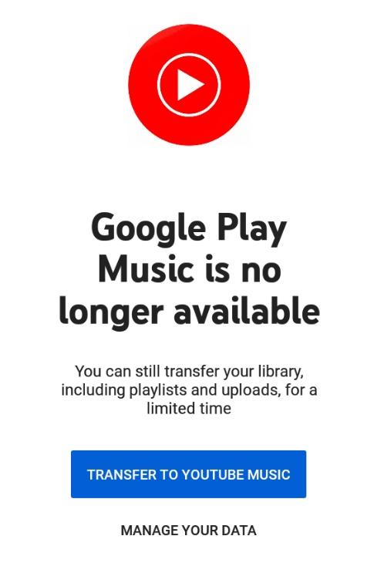
I started my Android experience on a Galaxy S5 phone, which I still own. That phone runs Android 6. I also own two Galaxy tablets, a recently purchased S5e running Android 10, and a much older A model running Android 8.1.0.
On February 1, 2021, I started the Play Music app on my Galaxy Tab S5e. The app displayed a screen stating that Play Music is "no longer available". The same announcement recommended installing the YouTube Music app.
You can see that screen in Illustration 1.
WHY I WON’T USE THE YOUTUBE MUSIC APP
YouTube is owned by Google. The intent of the YouTube music app is to play music stored "in the cloud".
There are three reasons why that cloud storage approach is not ideal for me.
First, that network-intensive method is a classic way for a dedicated fan of music to run into the ceiling on cell network data usage very quickly each month, with financial penalties for exceeding the ceiling, if your carrier contract has such a limit.
Second, despite claims that music stored in the cloud is available wherever you go, there are vast stretches of the US where data service is minimal or is completely absent. Drive through any mountainous area and that becomes obvious very quickly. With 5G, which has a much shorter range than 4G, that problem will be even more acute. The mountains will be the last place carriers build the extra towers necessary to make 5G work on every mile of interstates. Don’t count on that to happen on other mountain highways in the next ten years.
Third, there is a privacy issue. Music stored and accessed in the cloud is an invitation for the cloud storage provider to learn about one’s music preferences and monetize that knowledge, such as through endless ads.
WHAT GOOGLE DECIDED TO DO
I went to my desktop computer and googled the status of the Play Music app. I learned that, in 2020, Google announced that the company would no longer support the app as of December 3, 2020.
That end of support, by itself, does not cause the app to stop working. I use the Play Music app daily on my S10 phone. So far, the app still works just fine.
The fact that Google disabled the Play Music app on my Tab S5e tablet was quite an unhappy surprise. Even with the music indexing quirks in Play Music, which I wrote about a couple of years back, the Play Music app was reliable and reasonably easy to use.
I surveyed the fate of the Play Music app on my other Android devices. On the S10 phone, running Android 11, the app can still play my music collection stored on the phone. On the S5 phone, running Android 6, the app can still play my music collection stored on the phone. On my Galaxy Tab A, the app acted like the app on the Tab S5e, displaying the no longer available screen.
I expect that the end is near for the Play Music app on my current S10 phone and my old S5 phone.
THERE ARE MANY OTHER MUSIC PLAYER APPS
Of course, I went to the Google Play Store and looked for music player apps. That category is a huge, bewildering forest. The Play Store app recommended some alternative searches, including "music player no ads", so I tried that. Ads are another unwelcome use of cellular network data.
For each app, I looked at the review rating average, the number of reviews, and the total number of downloads. I also made sure that each was capable of playing music stored on the phone, not in the cloud.
Musicolet has been downloaded 5 million times and has a 4.7 rating average in almost 120,000 reviews. That is a very strong rating average. So I downloaded that app on my Tab 5e.
When I started the Musicolet app and worked through its setup steps, I learned that it has one feature I liked immediately. The app provides the option to specify one or more particular folders on the phone or tablet in which to find sound files. I chose the folder on my micro-SD card where I parked my 1,600+ songs (1,637, according to Musicolet). The advantage is that, unlike Play Music, the app will ignore my voice memos that are stored in a different folder. Play Music app automatically threw in all my voice memos, which are far less entertaining than my music.
Musicolet also offers a feature to play songs in random order, sometimes called Shuffle Play, just like the Play Music app. I use that constantly so that my music sounds like an FM progressive music station in the 1970s. I have other music on my phone as well, from the 1950s through the 2000s.
Another ad-free music player app with just about the same attractive stats is Pulsar Music Player. This one claims to support use on car sound systems via Android Auto.
Most sound systems in recent cars already provide Bluetooth capability. If you only want to access phone or tablet music, and you do not have the Android Auto feature in your car, you can play music from your phone on the car stereo via Bluetooth. Android Auto offers other advantages.
THE BOTTOM LINE
I hope other app publishers do not follow this disappointing Google precedent. When support is ceased, let the user base continue to enjoy the capabilities of the app, at least until an Android OS update breaks the app.
ABOUT THE AUTHOR: John Krout has been writing about creative uses of personal computers since the early 1980s. He worked for decades as a C and C++ developer for contractors of several federal government agencies. After more than a decade as a documentation writer for one such agency, he quit in April 2020 and now writes whatever he wants to. He resides in Arlington VA with his son, many computers and cameras, and too many cats.

